Data Analytics Assignment-2

Vaishnavi Dacharaju- 1309564

Question 1: Data Preprocessing in R
Perform following tasks:
- Write R code to explore attached WestRoxbury data in at least 5 ways. Check for missing data and outliers.
- Write R code to perform BostonHousing data exploration using basic and distribution charts

Loading the Data
First, we load the datasets into R and display the first few rows to get an initial look at the data.
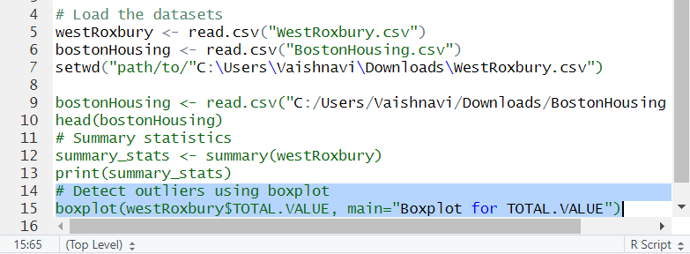
Data
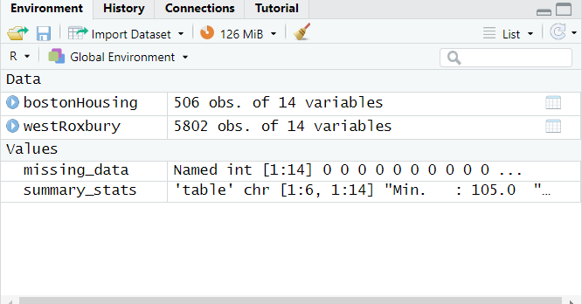

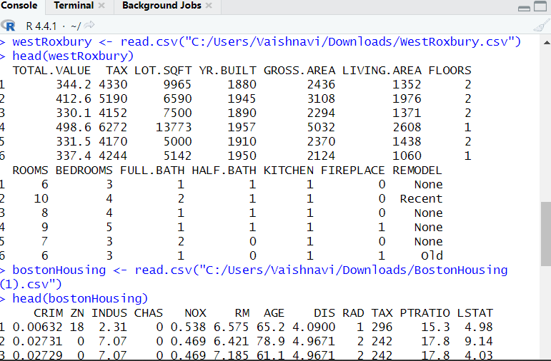

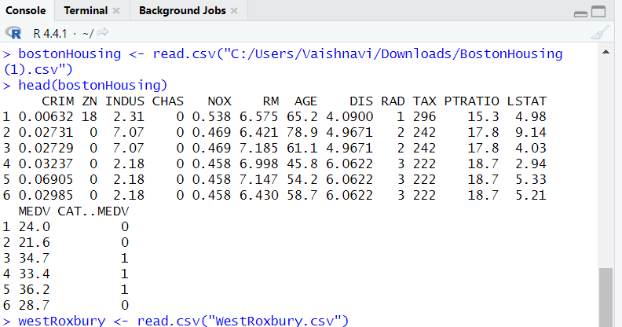

Checking for Missing Data
We check for missing values in each dataset to identify any potential data quality issues.
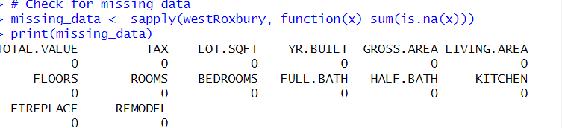

Summary Statistics
Next, we generate summary statistics for each dataset to understand the central tendency and dispersion of the data. 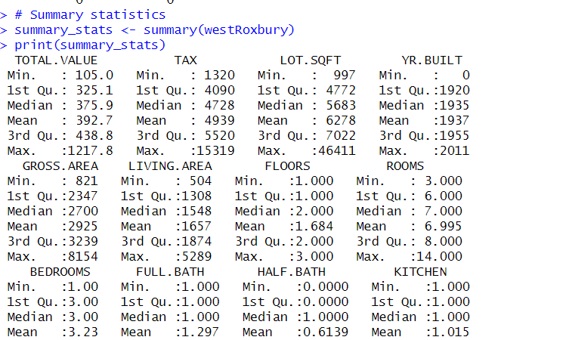

Identifying Outliers
We use boxplots to identify outliers in the numeric attributes of each dataset.

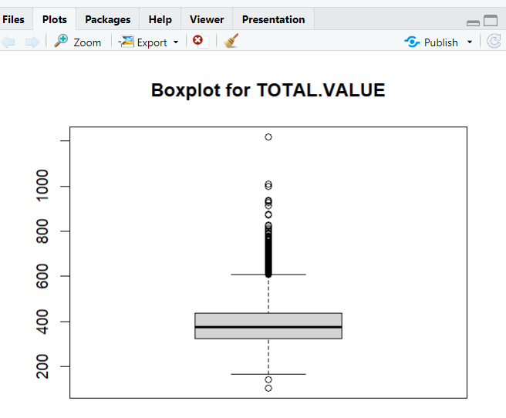

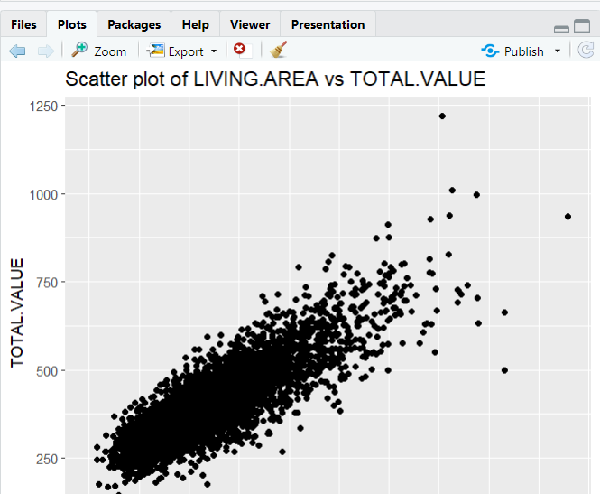

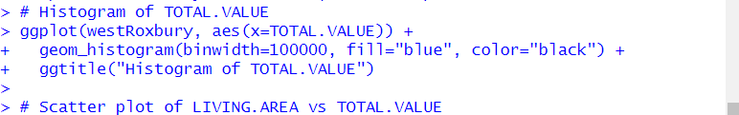

For Boston Housing

Summary Statistics
Next, we generate summary statistics for each dataset to understand the central tendency and dispersion of the data.
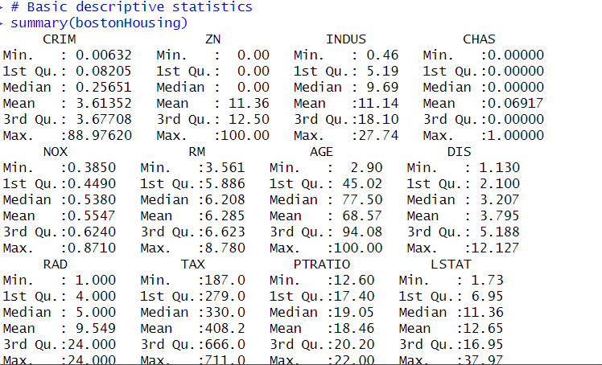

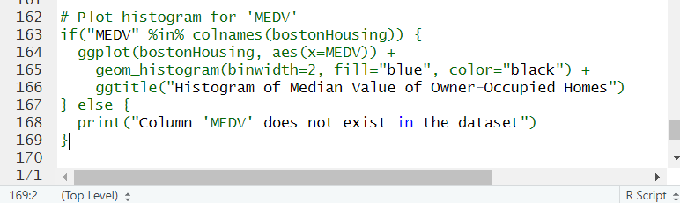

Identifying Outliers
We use boxplots to identify outliers in the numeric attributes of each dataset
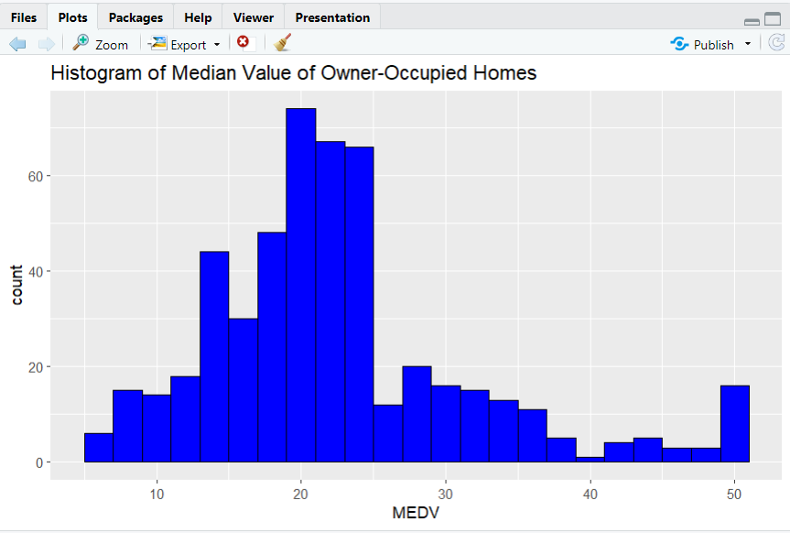

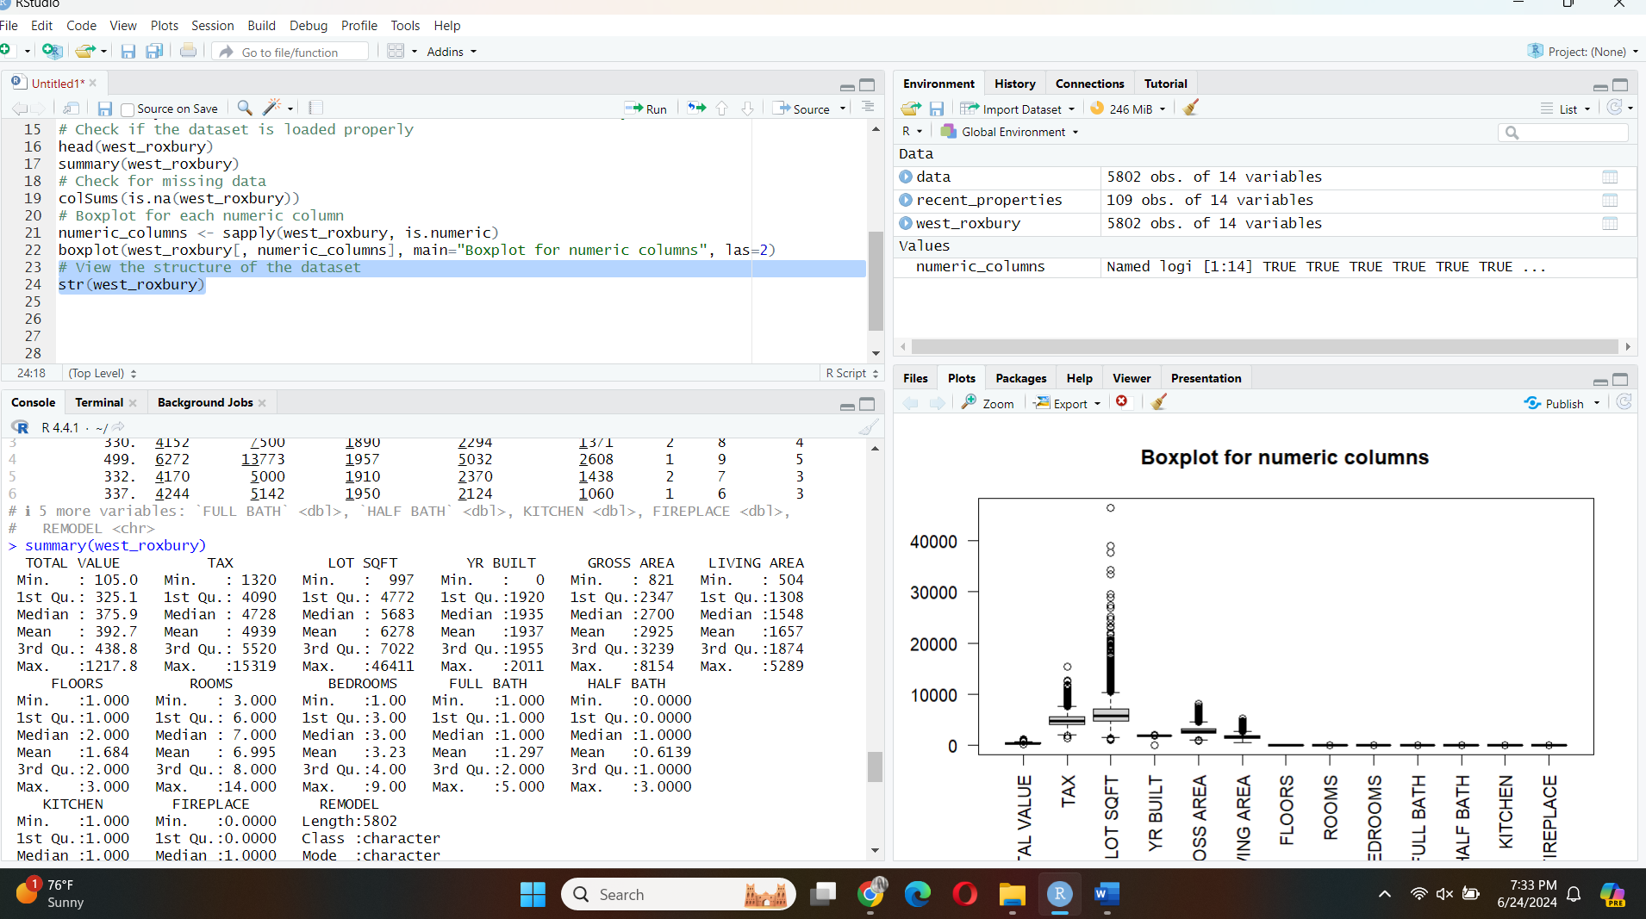

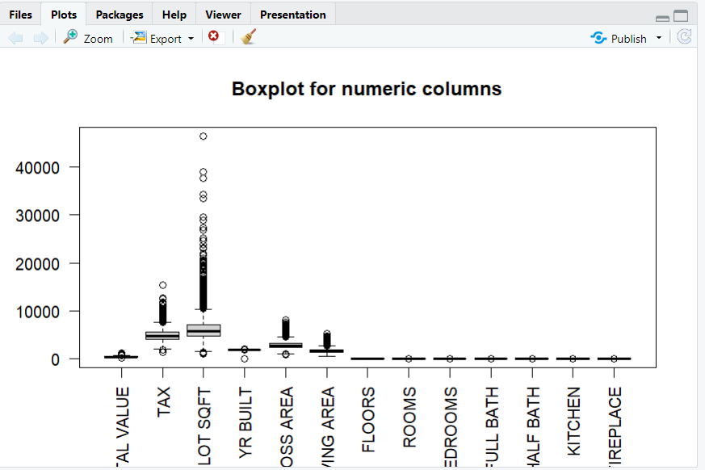
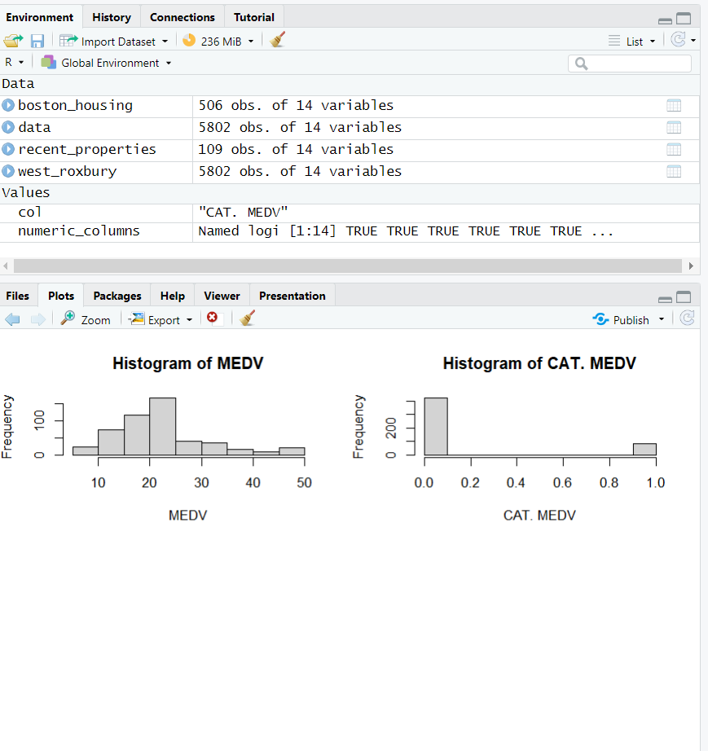
Scatterplot Matrix for dataset set in Boston
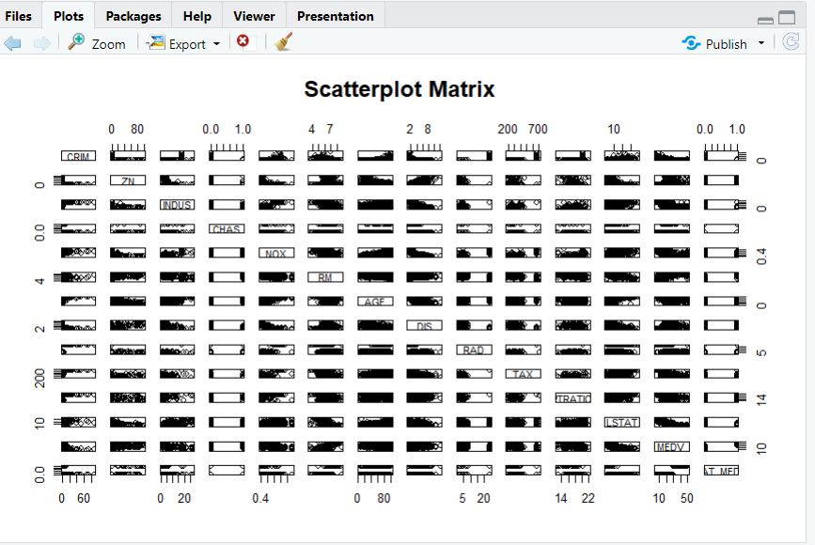

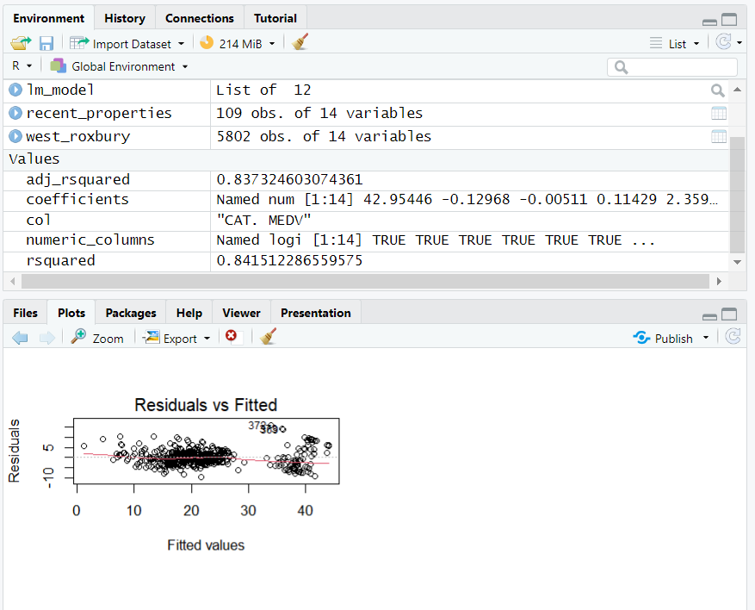

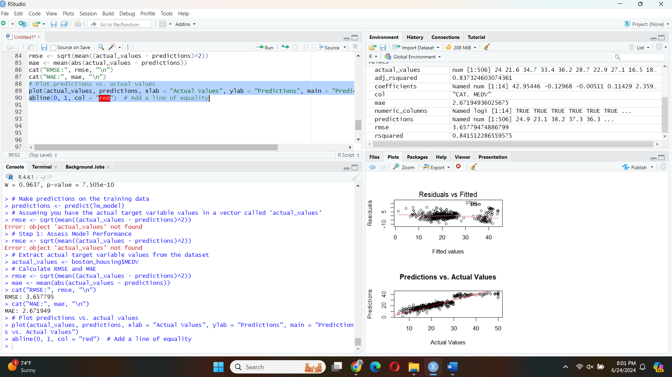
Boxplots
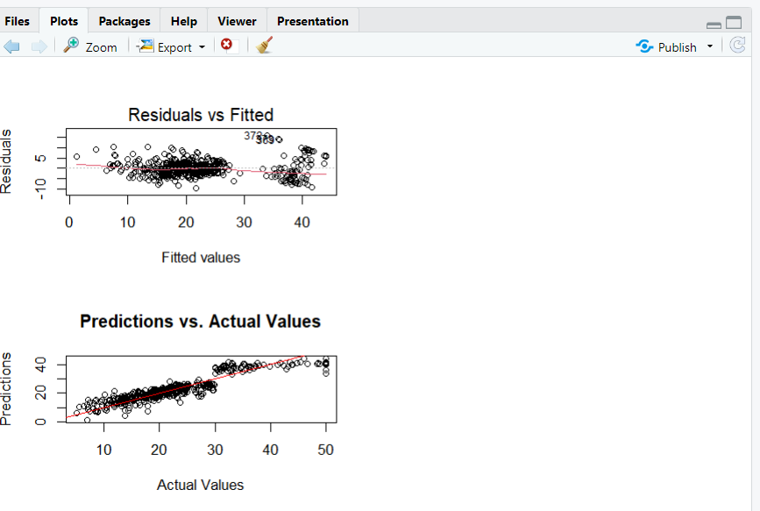
Data file
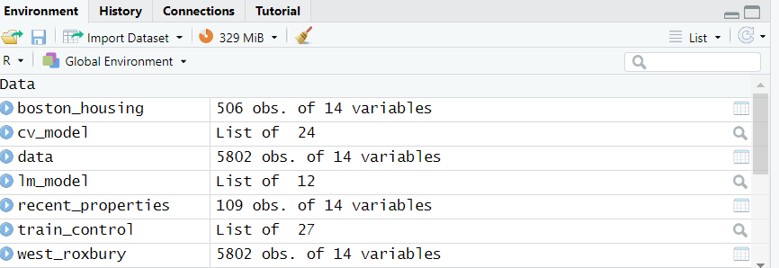

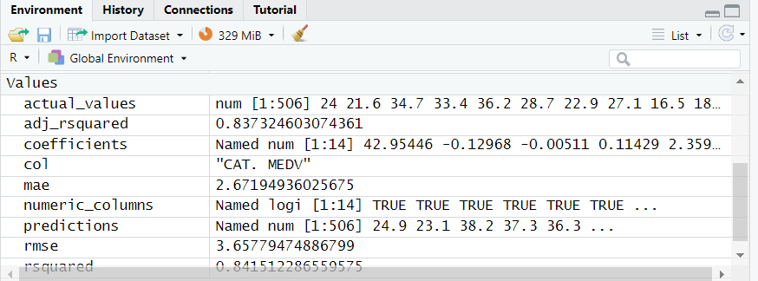

Question :2 Classification in R
Perform classification using decision tree classification algorithm:
- Explore data using boxplots, histograms, bar charts and correlation plots for at least four attributes
- Perform classification using decision tree classifier
- Evaluate the classifier
- Briefly describe the results
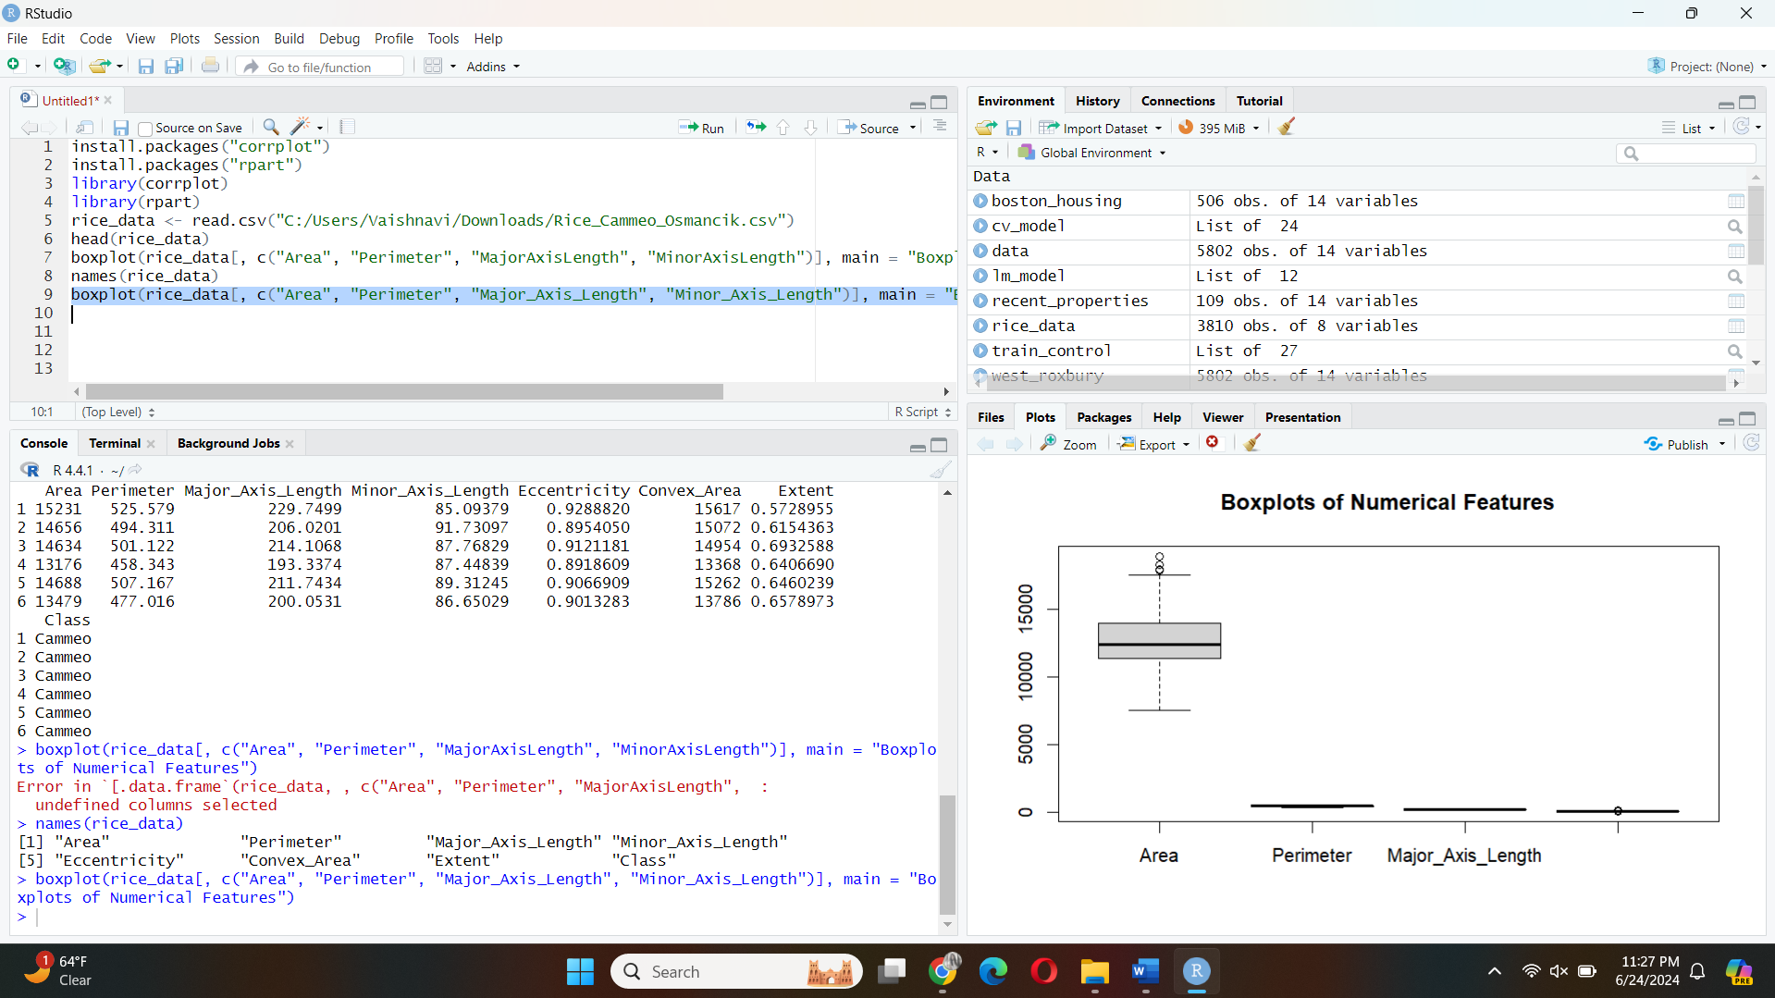

Data Exploration
Boxplots
We begin by visualizing the distribution of numerical attributes using boxplots.
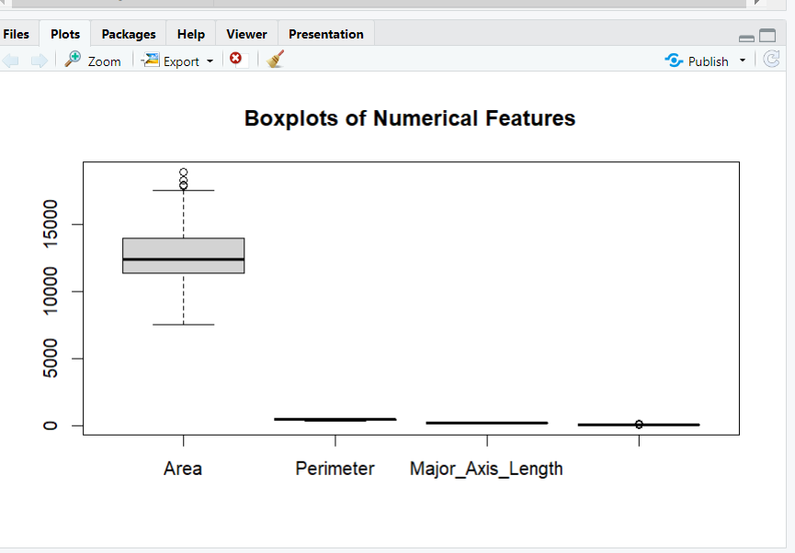
Histograms
Next, we create histograms for these numerical attributes to understand their distribution.
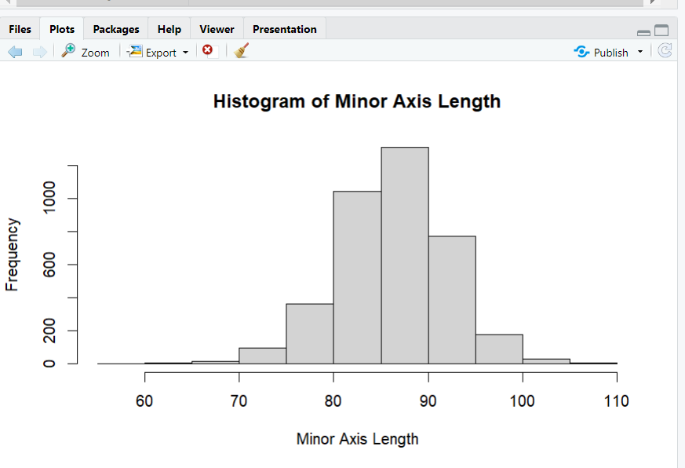
Correlation Plots
Lastly, we examine the correlation between the numerical attributes.
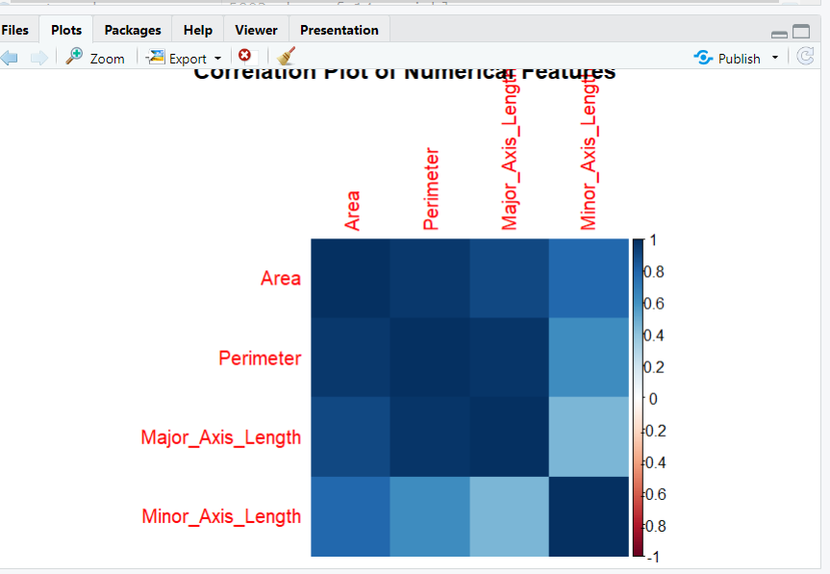

Model Evaluation
We evaluate the decision tree classifier by calculating the accuracy.
